# Background and Related Work

## Introduction

The popularity of arts and crafts is increasing among all age groups. Textile based hobbies, like knitting and embroidery are the 2nd most popular craft in the UK (Mintel, 2020). This statistic suggests that there is a market for an arts and crafts program. The objective of the project is to create a software that converts a picture into a cross stitch pattern. The user will be able to edit the pattern and customize it using different features of the program. This chapter reviews relevant literature about the topics in the project. It explains the basics of cross stitch, to gain an understanding of the fundamentals, and existing software. Another theme is about different methods for image downsampling, which will help to create the pattern. Different application platforms are evaluated, and UI design practices are explored.

## Cross Stitch History and Basics

For the purposes of this project a brief introduction to cross stitch is essential in order to understand how to implement the process digitally. Cross stitching is a type of embroidery stitch art (Setiabudi et al., 2017). A picture is created using colourful thread and little cross shaped stitches on fabric. Usually, two strands of cotton thread are used (Dyer, 1997). The stitching is done on fabric that has small holes: aida or evenweave (see Figure 1). The colour range of the threads can be vast, the most widely used is made by DMC. There are only a few types of stitches since the final result should look uniform. The simple cross is used most of the time, however, a half stitch, quarter stitch, three-quarter stitch and backstitching is also used occasionally (Atkinson & Roberts, 1999). Considering the different types of stitches used in this art form is important because they bear a close resemblance to the way that images are displayed on a computer screen because they both appear to be made of little squares (pixels).

Figure 1 - Example of a cross stitch on aida (RTO, n.d.).

This art-form originated in Asia, and the oldest cross stitch dates back to 850 B.C. It became more popular in the Victorian era. Then, in 1980 cross stitch re-emerged again, and became how we know it today. It is one of the most popular type of needlework throughout the world (Leslie, 2007). It is a soothing and therapeutic hobby, and could help improve mental health (Hohmann, 2020).

A pattern is needed to make a counted cross stitch (see Figure 2). A pattern consists of a grid with colourful squares (Biedl et al., 2005). The squares signal the position and colour of the stitch, like in Figure 3 (Atkinson & Roberts, 1999). The size of a pattern is measured by the number of stitches across and down.

Figure 2 - Simple cross stitch pattern (Fitzgerald, 2017)

Figure 3 – The way a pattern is converted to stitches (Biedl et al., 2005)

## Image Processing

Digital image processing means manipulation of an image with a computer. The cross stitch program will do exactly this: manipulating a photo into a pixelated version by compressing it. This section overviews some techniques and previous solutions to help with achieving the desired effect. Image compression is an application area of image processing. An image has to be resampled in order to upscale it, downscale it or rotate it. Downsampling is a widely used image operation. It is used to reduce the storage requirements (Youssef, 1999). However, it won’t be used in this project for that reason, but to get the pixelated look.

An image is stored in a bitmap. It is defined by the number of pixels and the information contained in them. Image scaling means to “re-sample a two-dimensional function on a new sampling grid” (Parthipan, 2017). Several algorithms can be used in image scaling. The simplest and fastest one is the nearest neighbour method, where the value of the new point becomes the value of the closest input point. Another method is linear interpolation, where the new point is interpolated between the two closest old points. Bilinear interpolation calculates the new point from the weighted average of the four closest input points. These might produce undesired effects like aliasing. A more sophisticated algorithm is bicubic interpolation. It samples the closest 4 by 4 pixels, so 16 pixels, and interpolates between them. This is the standard for most image editing software (Patil, 2018; Parker et al., 1983).

One of the simplest and most efficient downsampling algorithm is the box filter. It is a linear filter algorithm. This is considered to be used in the basic version of the program. The way it works is that each pixel in the target image is the average of the pixel values in a square from the source image. It is easier to understand with a diagram, see Figure 4.

Figure 4- Box filter (Parthipan, 2017).

This is a simple way of converting a picture into bigger squares like on a pattern, but this algorithm can easily miss important details, and the resulting image/pattern might not be recognizable. Other research tries to solve this problem by using more complex algorithms.

### Detail Preserving Resampling

This algorithm by Gertsner et al. (2012) converts high resolution images into pixel art style ones with reduced colour palettes. It converts faces and other detailed images much more accurately than a regular downsampling algorithm. Pixel art is very close to a cross stitch pattern, it almost looks identical without the grid, so this article can provide great ideas to approach the problem.

Each pixel needs to be carefully placed, so that it accurately represents the original image. Areas such as the eyes and mouth are especially difficult to get right, however, it’s achievable by using “superpixels”, see Figure 5. The algorithm uses an iterative process. First, the superpixels are initialized in a grid, and then each original pixel is assigned to the closest superpixel. The palette is also set to an average colour. Then, the iteration starts, the superpixels are refined and associated with colours in the palette, then palette is also refined, and expanded (Gertsner et al., 2012). Unfortunately, it doesn’t allow users to pick the palette colours, so that has to be solved in another way in the program.

Figure - Superpixels and final result (Gertsner et al., 2012).

### Posterization

Posterization reduces the number of tones used in an image. There is no gradient between the areas and usually vivid colours are used (Afifi, 2018; Kwon & Chien, 2011), see Figure 6. This algorithm can be useful for the program since it also needs to reduce the number of colours from the original image.

First, the algorithm of Afifi (2018) removes small details from the image, then applies bilateral filtering. After the image is prepared for quantization (the process to reduce the number of colours in an image to a limited palette) (Orchard & Bouman, 1991), the pixels are sorted into ‘bright’, ‘grey’, and ‘dark’ categories using fuzzy logic.

Figure - Posterized image (Kwon & Chien, 2011).

## Application Platforms for Consideration

### .NET Framework

A suitable application platform needs to be selected for the software. This desktop application will be Windows based, so the Microsoft .NET Framework will be used. Figure 7 illustrates the .NET stack. This technology supports running Windows and Web apps (Microsoft Docs., 2020). Both WPF and Windows Forms are part of the framework, however, they are best suited for different types of applications (Misra, 2016). Both of these platforms are evaluated and considered for the project below.

Figure 7 - .NET Framework (Soumyasch, 2007).

### Windows Forms

Windows Forms was released by Microsoft in 2002 as part of the .NET framework. This greatly influenced how Windows applications are written, explains Griffiths and Adams (2003). Before Windows Forms developers could only use Win32 to make Windows applications, this is lower level and does not have a GUI (Graphical User Interface). By increasing the level of abstraction, a higher-level object-oriented API was created. This makes it much simpler to develop an application, allowing to concentrate on the task rather than the low-level details. In Visual Studio developers can make use of the Windows Form Designer, where they can drag and drop controls into the UI. WinForms is event driven, so when the user interacts with the interface, for example, clicking a button, an event occurs. The application processes these events with the help of event handlers, which are programmed in C# or other high-level languages (Microsoft Docs., 2017).

### WPF

WPF (Windows Presentation Foundation) is a Graphical User Interface framework (Misra, 2016). It was released in 2006 with the new .NET 3.0 framework (Xu, 2010). The expectations for user interfaces were increasing, so new technology was needed, according to Nathan (2010). The user interface needed to be separated from the implementation, so that programmers and designers could work on the application without relying on one another. As an answer to this Microsoft released WPF. The user interface design is done in XAML (Extensible Application Markup Language), completely independent of the code. XAML is an XML based markup language designed for WPF (Microsoft Docs., 2016). This way the development is more efficient, and the cost is reduced. It is also easy to understand for designers. It is much more powerful than Windows Forms since it supports documents, multimedia, 2D and 3D graphics and animation (Xu, 2010). Before it would have required several different technologies to make an application containing all these. WPF is built on Direct3D, so it can provide high performance graphics.

### Comparison

The decision about which platform to use depends on the requirements of the application. WPF allows sophisticated UI design, while in WinForms the UI is not as customizable. UI is an important part of the program, so extensive customizability is preferred. WPF supports multimedia and graphics, while WinForms would need a third-party control to do the same. The cross stitch program mainly deals with images, so support for that is essential. WinForms uses less memory than WPF, however, memory is not a primary concern. WPF might have a steeper learning curve, and has less documentation, but it still proves to be the right choice for developing the application (Misra, 2016; Microsoft Docs., 2019).

## User Interface

A user interface allows the user to interact with the program (Galitz, 2007). It is part of the field of Human Computer Interaction. This topic needs to be researched in order to be able to design a good UI for the program. A good UI means one that has a well-functioning input and output mechanism and lets the user accomplish tasks without putting any obstacles in their way (Gunderloy, 2006).

The most widely used type of UI is a Graphical User Interface (GUI). The first successful system using it was released by Apple in 1984. It includes lots of visible clues (buttons, windows, mouse) and real-world analogies (like dragging a file into a trash can meaning deleting it) (MacDonald, 2008).

The main aim for it is to be intuitive and logical. It is also important to be consistent within the application and with other popular software (like Word). The reason for this is that users already learnt the layout and menu organization of them, and it would slow them down by having to learn a completely new UI (Gunderloy, 2006). The UI cross stitch program will be similar to widely used drawing programs like Photoshop (see Figure 8) or Paint Tool SAI, since it is also a type of art program.

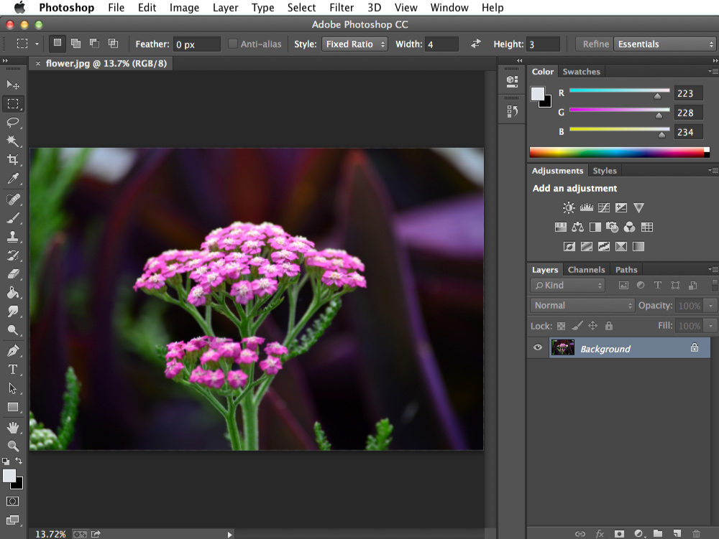

Figure 8 - Photoshop User Interface (GCFGlobal, n.d.)

Another general principle for UI design is to be aesthetically pleasing. This is an important aspect of the project. It can be achieved by using colour and graphics effectively. It also helps to convey messages clearly.  
Limiting the ability to make mistakes can greatly improve usability. The UI needs to be forgiving and always have an option to undo an action. Finally, a simple design helps to not confuse new users by not overwhelming them with an overcrowded interface. Limiting the number of things the user has to remember also helps to reduce memory work (Galitz, 2007).

Identifying the user base is also vital for the success of a program (MacDonald, 2008). More influential factors for the project are the users’ familiarity with the computer, frequency of use, gender, and age. The users of a cross stitch software will mostly be discretionary users, so it will only be used if the benefit of using it exceeds the effort learning it, according to Galitz (2007).

Failing to use the principles will make the UI inefficient and people will have difficulty doing their job. They might even stop using the program.

### Colour

Colour can be really powerful. It can convey emotions without saying anything (Barševska & Rakele, 2019). It is not a surprise that it has a great impact on the mood and behaviours of users. It provides structure and meaning to the screen. Research proved that colour in user interfaces improves performance and aids memory (Galitz, 2007). However, some combinations can strain the eye, so it is important to study colour theory to make the right decisions. There are different ways of selecting a good colour scheme. Based on colour theory, there are the following main combinations (see all of them in Figure 9):

* Monochromatic, which uses one colour with different hues.
* Complementary, which combines contrasting colours (red, green). It is difficult to harmoniously combine them in a UI.
* Split complementary, where a primary colour is used with two analogous colours to its complement.
* Triad combines three colours on the colour wheel with equal distance from each other.

Figure 9 - Colour combinations (Barševska & Rakele, 2019).

It is recommended to start designing the UI in black and white first. This helps focusing on the layout and simplifies the process. When the design is ready, then start adding colours as needed, but only with meaningful purposes. However, no more than five colours should be used. Avoiding pure black is encouraged since it looks unnatural. Keeping in mind the common meaning of colours will help the design. For example, red usually has meanings like stop and danger, so it shouldn’t be used for an OK button (Barševska & Rakele, 2019).

## Existing Cross Stitch Software

This section provides an overview of existing cross stitch pattern making software. Knowing what is currently available will help inform this project. There are a number of cross stitch pattern making software on the market with varied quality and features. The most popular and advanced one is WinStitch/MacStitch (2019). This is a commercial software, and it is regularly updated. Another example is PC Stitch (2016), which was the preferred software until it stopped getting updates. Both can be quite expensive for a hobbyist, so a good alternative can be free, open-source software. These generally have less features and not as clean UI (user interface); however, they can still create a pattern. These include XStitch (Chestnut Pens, 2020) and CStitch (Klein, 2017).

All of the above software can convert a picture into a pattern. WinStitch has a wide range of features and a professional looking UI, so it is a good source of ideas for this project. Some features proving very useful are the ability to select the size of the pattern before generating it, as well as the number of colours used. These types of features are ones that will need to be considered in the design phase of this project. WinStitch uses real thread colours in the pattern, this makes it very practical for the user to buy supplies. See on Figure 10 that the thread colours are as close as possible to the original painting, and how detailed the pattern is. There are also a lot of options to edit the pattern, from changing thread colours to drawing on it. The biggest differences between the free and commercial applications are the number of features and how the user interface looks. WinStitch’s UI is very sleek and intuitive, while CStitch’s is quite antiquated and sometimes hard to use. One of the aims here is to design an attractive UI with all suitable features without having too many options that may overwhelm the user. The intention for this project is to be a good middle ground for users, available at a lower price while still maintaining quality.

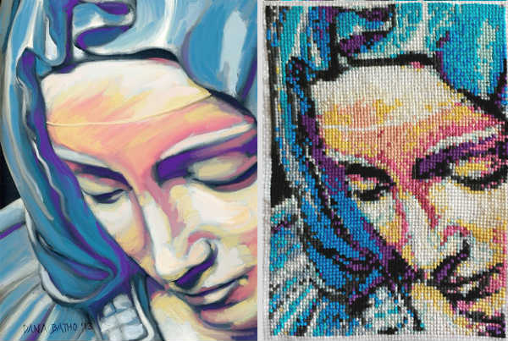

Figure 10- Painting and cross stitch. Pattern created in WinStitch (Batho, 2014)

## Summary

After reviewing and analysing past literature about relevant topics, I am more prepared to design and implement the application. A simple resampling algorithm can be used for the basic implementation and fast performance, however, a more advanced one is preferred to preserve detail. WPF enables developers to build a robust application with advanced graphics and highly customized UI. This is ideal based on the requirements of the project, therefore WPF will be used instead of Windows Forms. The UI needs to be simple, so that novice users can interact with it easily, and optimal colour palettes need to be considered for a harmonious look.

References

Afifi, M. (2018). Image Posterization Using Fuzzy Logic and Bilateral Filter. *arXiv preprint arXiv:1802.01009*.

Atkinson, K. R., & Roberts, J. C. (1999). Graphics and Visualization within Cross-Stitch. In Eurographics UK, Conference Proceedings, 1999 (pp. 129-141). Eurographics.

Barševska, Z., & Rakele, O. (2019). COLOR IN UI DESIGN. *PROCEEDINGS OF THE 61st INTERNATIONAL SCIENTIFIC CONFERENCE OF DAUGAVPILS UNIVERSITY*, 79.

Batho, D. (2014). Pieta [painting and cross stitch]. <https://peacockandfig.com/2015/02/from-a-painting-to-a-cross-stitch/>.

Biedl, T. C., Horton, J. D., & López-Ortiz, A. (2005). Cross-Stitching Using Little Thread. In *CCCG* (pp. 199-202).

Chestnut Pens (2020) Cross Stitch Chart Creation Program. Retrieved from: http://www.chestnutpens.co.uk/misc/index.html.

*Choose your Windows app platform - Windows applications | Microsoft Docs*. (2019). Retrieved November 24, 2020, from <https://docs.microsoft.com/en-us/windows/apps/desktop/choose-your-platform>.

Dyer, K. (1997). Counted Cross Stitch Tutorial. Retrieved November 18, 2020, from: [https://www.crosstitch.com/nfaq/nfaq1.html#](https://www.crosstitch.com/nfaq/nfaq1.html).

Fitzgerald, S. (2017). A beginner’s guide to cross stitch – Red Gate Stitchery. Retrieved November 18, 2020, from https://redgatestitchery.com/blogs/red-gate-stitchery/a-step-by-step-guide-to-cross-stitch.

Galitz, W. O. (2007). *The essential guide to user interface design: an introduction to GUI design principles and techniques*. John Wiley & Sons.

Gerstner, T., DeCarlo, D., Alexa, M., Finkelstein, A., Gingold, Y. I., & Nealen, A. (2012). Pixelated image abstraction. In *Expressive* (pp. 29-36).

GFCGlobal (n.d.) Photoshop User Interface [Online image]. GCFGlobal. https://edu.gcfglobal.org/en/photoshopbasics/getting-to-know-the-photoshop-interface/1/.

Griffiths, I., & Adams, M. (2003). *NET Windows forms in a nutshell*. " O'Reilly Media, Inc.".

Gunderloy, M. (2006). *Developer to designer: GUI design for the busy developer*. John Wiley & Sons.

Hohmann, J. (2020) “We are all mad here”: A Content Analysis of Facebook Posts and Comments about the Impact of the Fibre Arts on Mental Health and Wellness.

*Introduction to WPF | Microsoft Docs*. (2016). Retrieved November 26, 2020, from https://docs.microsoft.com/en-gb/dotnet/desktop/wpf/introduction-to-wpf?view=netframeworkdesktop-4.8.

Klein, T. (2017) Cstitch. Retrieved from: http://cstitch.sourceforge.net/index.shtml.

Kwon, O. Y., & Chien, S. I. (2011). Improved posterized color images based on color quantization and contrast enhancement. In *Proc. Int'l Conf. Machine Vision, Image Processing, and Pattern Analysis* (Vol. 5, pp. 1203-1206).

Leslie, C. A. (2007). Needlework through history: An encyclopedia. Greenwood Publishing Group.

MacDonald, M. (2008). *User Interfaces in C#: Windows Forms and Custom Controls*. Apress.

MacStitch and WinStitch. (2019). Retrieved November 18, 2020, from <https://www.ursasoftware.com/macstitch/index.html>.

Mintel (2020). Hobbies and Interest – UK – February 2020. Retrieved from Mintel Reports database.

Misra, A. (2016). Use of Windows Presentation Foundation and Windows Forms in Windows Application Programming. *International Journal of Advanced Research in Computer Science*, *7*(7).

Nathan, A. (2010). *WPF 4 unleashed*. Pearson Education.

Orchard, M. T., & Bouman, C. A. (1991). Color quantization of images. *IEEE transactions on signal processing*, *39*(12), 2677-2690.

*Overview - Windows Forms .NET Framework | Microsoft Docs*. (2017). Retrieved November 25, 2020, from <https://docs.microsoft.com/en-us/dotnet/desktop/winforms/windows-forms-overview?view=netframeworkdesktop-4.8> .

*Overview of .NET Framework | Microsoft Docs.* (2020). Retrieved November 23, 2020, from https://docs.microsoft.com/en-gb/dotnet/framework/get-started/overview.

Parker, J. A., Kenyon, R. V., & Troxel, D. E. (1983). Comparison of interpolating methods for image resampling. *IEEE Transactions on medical imaging*, *2*(1), 31-39.

Parthipan, V. (2017). Image Down-Scaler Using the Box Filter Algorithm.

Patil, M. (2018). Interpolation Techniques in Image Resampling. International Journal of Engineering and Technology. 7. 567-570. 10.14419/ijet.v7i3.34.19383.

PCStitch: Premier Cross Stitch Software. (2016). Retrieved November 19, 2020, from http://www.pcstitch.com/PCS10/PCStitch10.aspx.

RTO (n.d.). RTO Iris Flower Cross Stitch Kit-4-inch x 4inch, 14 Count [Online image]. Amazon. <https://www.amazon.co.uk/RTO-Flower-Stitch-Kit-4-inch-4-inch/dp/B00EW4NCEG>.

Sells, C., & Weinhardt, M. (2006). *Windows Forms 2.0 Programming (Microsoft Net Development Series)*. Addison-Wesley Professional.

Setiabudi, D., Isa, S. M., & Iswanto, B. H. (2017). Digital color classification for colorful cross stitch threads using RGB+Euclidean Distance and LAB+CIE94. Proceedings of 2016 International Conference on Information and Communication Technology and Systems, ICTS 2016, 150–156. <https://doi.org/10.1109/ICTS.2016.7910290>.

Soumyasch (2007). The .NET Framework stack [Online image]. Wikipedia. <https://en.wikipedia.org/wiki/.NET_Framework_version_history#/media/File:DotNet.svg>.

Xu, J. (2010). Practical WPF Charts and Graphics. In *Practical WPF Charts and Graphics*. Apress. <https://doi.org/10.1007/978-1-4302-2482-2>.

Youssef, A. (1999). Image downsampling and upsampling methods. *National Institute of Standards and Technology*.